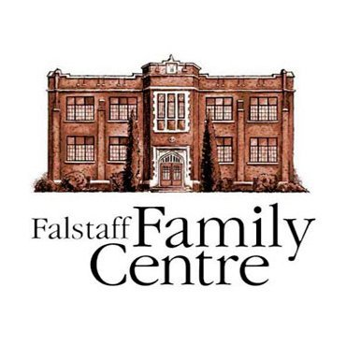

**2023**

**Rental Application Form**

**Falstaff Family Centre**

35 Waterloo Street North

Stratford, ON N5A 5H6

Canada

(Tel) 519-273-3876

(Toll Free) 1-800-361-7959

(Fax) 519-273-4553

info@falstaff.ca

[www.falstafffamilycentre.com](http://www.falstafffamilycentre.com)

**Falstaff Family Centre**

Fee For Service Rental Application

**Rental Application Note:** Before completing the form, please read the attached Rental Terms and Conditions. Submit Application along with Certificate of Insurance. Confirmation of application will be made by a FFC representative.

**ORGANIZATION: ________________________________________________________________________________**

**CONTACT INFORMAITON:**

NAME: **_________________________________** PHONE: **____________________________________**

ADDRESS: **_________________________________** FAX:: **____________________________________**

**_________________________________** EMAIL: **____________________________________**

**TYPE OF EVENT/ACTIVITY:** ________________________________________________________________________

**ROOM: □** Community Room **□** Kitchen **□** Grounds **□** Basement Classroom

**DATE(S) REQUESTED: TIME(S) REQUESTED:**

_____________________________________ FROM: ______________ TO: ______________

_____________________________________ FROM: ______________ TO: ______________

_____________________________________ FROM: ______________ TO: ______________

**ANTICIPATED #:** ADULTS: ______________ CHILDREN: ____________

**WILL THE EVENT REQUIRE HANDICAPPED ACCESS? □** YES **□** NO

**Do you have insurance for the duration of the agreement?**  **□** YES **□** NO Please submit one week prior to event

**Do you require a Liquor License?**  **□** YES **□** NO Please submit one week prior to event

**REQUIRED #:** TABLES: __________CHAIRS: __________ AUDIO/VIDEO: ___________ PIANO: ___________

**Payment**: Invoices will be billed monthly at the beginning of each month and are due upon receipt

I, the Applicant(s), have read the Policies Terms and Conditions under which this Rental application is being made and I hereby accept full responsibility for the obligations stated therein.

SIGNATURE: ______________________________ SIGNATURE: ______________________________

APPLICANT: ______________________________ STAFF

THE FALSTAFF FAMILY CENTRE

DATE: ______________________________ DATE

Information collected of this application form is collected by the Falstaff Family Centre and will be used by the Centre to review and process applications for rental of space in the Falstaff Family Centre. The Falstaff Family Centre reserves the right to refuse any rental application.